**FATHER SATURNINO URIOS UNIVERSITY**

Tel. No. (085) 342-1830 LOCAL 1943

www.urios.edu.ph

San Francisco St., Brngy. Sikatuna, Butuan City 8600,

CARAGA Region, Philippines

**COMPUTER STUDIES PROGRAM**

A Terminal Report of the

On-the-Job Training (OJT) undertaken at

Engtech Global Solutions Inc.

**JESUIT KRIA M. VILLALUZ**

Submitted to the Faculty of Computer Studies Program

Father Saturnino Urios University

In partial fulfilment of the requirements for the degree of

Bachelor of Science in Information Technology

**2019**

**APPROVAL SHEET**

A Terminal Report of the **ON-THE-JOB TRAINING** at the **Office of ENGTECH GLOBAL SOLUTIONS INC.** prepared and submitted in partial fulfillment of the requirements for the degree BACHELOR OF SCIENCE IN INFORMATION TECHNOLOGY (BSIT) by **JESUIT KRIA M. VILLALUZ** is hereby recommended for acceptance.

**MR. DOMINIC R. GUIRITAN**

Practicum Instructor

______________________

Date Signed

Accepted as partial fulfilment of the requirements for the degree BACHELOR OF SCIENCE IN INFORMATION TECHNOLOGY (BSIT).

**LAMBERTO C. BOLIGOR, MSIT**

Dean, Computer Studies Program

______________________

Date Signed

**ACKNOWLEDGMENT**

Allow me to thank the people first behind the success of being here at Engtech Global Solutions, Inc. and for making our OJT a possible one. First and foremost to our Almighty God, for giving us strength every day, for the guidance and good health, for the graces and blessings that help us to perform our task as part of our OJT.

To my family, my deepest gratitude and appreciation for being with us all through the way from the beginning and for showing your unconditional love and unending support financially, emotionally and spiritually.

To my co-ojt, May Jane Doquila, Lorraine Joei M. Senturias, Computer Science and IT OJT’s from AMA College of Butuan that wishes to acknowledge with sincere gratitude and heartfelt thanks to the person who helped me during my OJT period.

To the Engtech Global Solutions, Inc. family, thank you for your warm welcome and for giving me this one of a kind experience in having our OJT in your company. For the chance that you have given us to be with your team and for giving us more knowledge in this fast and furious world of Information Technology. And most especially for helping me to hone our knowledge as we continue to strive in our ambitions in life.

To our project manager, Mr. Jovanni Bayawa and project coordinator, Mr. Niño Jabagat, for the guidance and for helping me also to be here at Engtech Global Solutions, Inc. and for giving me a chance to explore the real world of Information Technology.

**DEDICATION**

Despite of many efforts, trials and hardships during my training, I would like to dedicate this accomplishment and success to the Almighty God my creator, my strong pillar, my source of my strength throughout this program and on His wings only I have soared. I also dedicate this work to my loving parents for their moral and financial supports and to my best friend; Bai Sittie Hadeeya Balono who has encouraged me all the way and whose encouragement has made sure that I give it all it takes to finish that which I have started. To Engtech Global Solutions, Inc. for giving me a chance to share and dedicate my ideas and learnings I learned in the abilities and knowledge in relation to office and computer works, and to my co-trainees who became part of my daily activities in my on-the-job training.

**TABLE OF CONTENTS**

|  |  |  |
| --- | --- | --- |
|  | |  |
|  | | Page |
| **I.** | **TECHNICAL DESCRIPTION** |  |
|  | 1. Title Page | ii |
|  | 1. Approval Sheet | iii |
|  | 1. Acknowledgment | iv |
|  | 1. Dedication | v |
|  | 1. Table of Contents | vi |
| **II.** | **COMPANY PROFILE** |  |
|  | 1. Brief History of the Company | 1 |
|  | 1. Nature and Objectives of the Company | 3 |
|  | 1. Organizational Structure | 5 |
| **III.** | **TRAINING MANAGEMENT** |  |
|  | 1. Introduction | 6 |
|  | 1. Trainee’s Area of Concern | 8 |
|  | 1. Primary | 8 |
|  | 1. Secondary | 8 |
|  | 1. Description of the developed project | 9 |
|  | 1. DETAILED Narration of Experience | 9 |
|  | 1. Knowledge and Competency Acquired | 13 |
|  | ii. Values Learned | 14 |
|  | 1. Problems encountered and proposed solutions | 14 |
|  | 1. Technical | 14 |
|  | 1. Administrative | 14 |
|  | 1. Conclusions | 15 |
|  | 1. Recommendations | 15 |
| **IV.** | **Appendices** |  |
|  | 1. Action Photos and Screen Shots | 20 |
|  | 1. Daily Time Record (DTR) |  |
|  | 1. Processing Forms (Endorsement Letter, Waiver, OJT Site Letter of Request) |  |
|  | 1. Certificate of Completion |  |
|  | 1. Filled-up Evaluation Form |  |

**II. COMPANY PROFILE**

**Brief History of the Company**

The ACLC College of Butuan (ACB) franchised by Butuan Information Technology and Services Inc. (BITSI) aims to produce competitive IT and Technopreneur graduates in the Southern part of Mindanao. To further strengthen the backbone of its graduates the management initiative is to put up a software solution company – EngTech Global Solutions Inc. to cater and immerse its students and faculty to the standards of the software industry.

With the series of projects being implemented by the company with the different requirements of its clients. The company has created its portfolio and has been proven with its successful implementation of the software.

**Nature and Objectives of the Company**

**Company Overview**

Engineering Technology (EngTech) Global Solutions Inc. is a software company located in J.C. Aquino Avenue, Butuan City that provides custom application development services. Offering a full-cycle application development from requirements elicitation to product design and development down to the quality assurance testing deployment and further maintenance.

A team of professional IT experts assist in choosing the most appropriate solution in accordance with the customers’ needs.

Having successfully implemented number of projects for local and national clients, Engtech’s team acquired a unique experience in custom application development across various domain areas, including:

* Retail
* E-commerce
* Construction and Real Estate
* Healthcare

Engtech’s expert team helps you consider all the appropriate technologies and platforms to choose for your project aims, size and budget solution. Our mission is to work close to the customer to identify all the requirements and needs which includes their technology preference.

Whether your company is thinking of establishing a simple online presence or considering a complex enterprise solution, our team is at your service.

**Organizational Structure**

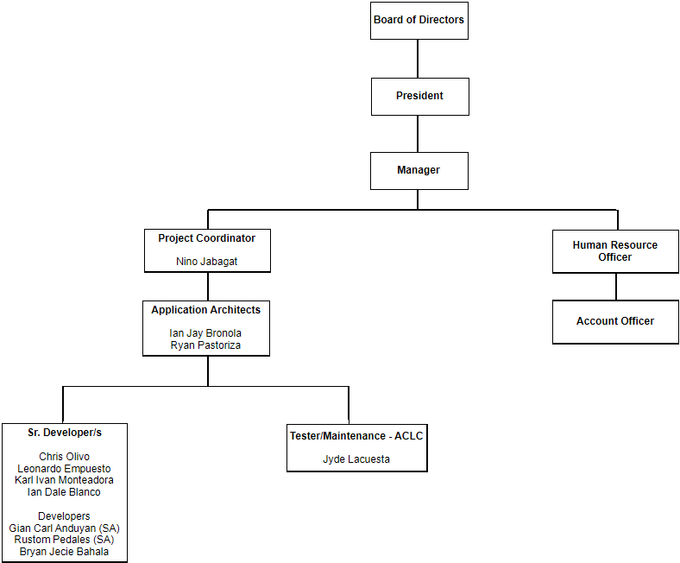

**III. TRAINING MANAGEMENT**

1. **Introduction**

On-the-job training (OJT) is a form of training taking place in a normal working situation. OJT, sometimes called direct instruction, is one of the earliest forms of training (observational learning is probably the earliest). It is a one-on-one training located at the job site, where someone who knows how to do a task shows another how to perform it. In antiquity, the work performed by most people did not rely on abstract thinking or academic education. Parents or community members, who knew the skills necessary for survival, passed their knowledge on to the children through direct instruction.

OJT is very important not only to teach students their chosen career but to show students the reality about working. This is the most important part of a course, which the student can measure the learning based on what they learn in university or learn more about their specialization. By OJT, students can experience a little bit work or how the real IT works and Office works.

Doing OJT in Engtech Global Solutions, Inc. guides the trainee’s to develop their skills and knowledge with their related field, not only skills and knowledge but also in personality, it is also help to experience them the real jobs and actual working environment, and also confidence to the job. They not just trained the trainee to do their required task but also trained on how to act professionally.

1. **Trainee’s Area of Concern**

The Production and Testing division provides system development and testing for all the company’s client. Also, this division provides planning, documentation, and reports of the entire ongoing project. This is where the trainee was assigned.

1. **Primary**

Project Development

1. **Secondary**

Data Entry

1. **Description of the Developed Project**

The assigned project was a Queuing System. To be able to be served, the users must acquire a queue number and wait until the said number will be called. The process of calling the numbers is first-come, first-served, in the order of the queue numbers wherein the one who comes first, will get the first priority (queue number), hence, will be served first. The progress of the service depends on the stations/windows that are available for serving. Queuing system controls the distribution of queue numbers at the same time manages the service for proper arrangement of transaction.

The system can handle single transaction per queue number at a time. Each printed queue number will have a transaction. The queue numbers are handled and be printed in a Kiosk. The system also handles the calling of the next in queue, however, it will be controlled by authorized persons. Transferring of transactions to the other Offices is also possible with the system. Adding entities, accounts and ads, will all be controlled by the System administrators.

1. **Detailed Narration of Experiences**

1st Week (November 26-30, 2018)

During this week I met my co-OJT’s from AMA College of Butuan. Our project coordinator, Sir Niño Jabagat conducted a conference with May Jane, Lorraine and I about the upcoming project, which is a queueing system. We discussed the modules of the system and what are the possible actions for each functions, the best framework for implementation and also had some suggestions for the design and modifications to enhance the interface.

2nd Week (December 3-7, 2018)

This week, Sir Jabagat assigned me to list the functions and actions of each module and adjusted the timeline of developing the project. My tasks included to begin learning LARAVEL. I read and watch tutorials because we will be using this framework for the project. I discovered more about LARAVEL, some of the features are a modular packaging system with a dedicated dependency manager, different ways for accessing relational databases, utilities that aid in application deployment and maintenance, and its orientation toward syntactic sugar.

3rd Week (December 10-14, 2018)

This week, we met with our project coordinator to discuss about the project and assign task for both May Jane and me. We also met with the developer, Gian, and guide us since we are having a hard time to use the framework and integrating the design of the queueing system. I began working on filtering the numbers for senior citizen and regular and printing the queue number.

4th Week (December 17-21, 2018)

This week, Sir Jabagat discussed for additional information about the flow of the system, and the entity relationship of diagram. The main developer of the project, Gian, told us to change the framework, instead of LARAVEL we used the Code Igniter. Which is better, since we are quite familiar and we learn it from school.

5th Week (January 7-11, 2019)

This week, the enrollment in ACLC is ongoing. Data entry is our new task, and one of the developers of Engtech, Rustom Pedales, gave us instructions and explain to us how the enrollment system of ACLC works. May Jane, Lorraine and I are temporarily transferred to OSAS to enter and update some of information of students. At times, the internet is slow and it make our progress slow. But we managed to finish the task, and inputted the data correctly and on time.

6th Week (January 14-18, 2019)

The enrollment is still on going and the list of students that should be updated is very long, so we doubled our time to work faster. At times he system is having a problem when saving the information. The session of system interrupts when inputting and saving the data because you have to refresh the page and start inputting the information all over again. But patience is a virtue, so we wait and do the work duly and finish it on time.

7th Week (January 21-25, 2019)

We continue entering data and this week there are only few students that are enrolling. It is not hard for us and we finish it on time.

We had a general cleaning to keep the office clean and healthy workplace. We sweep the floors, blast dust out of tight spaces and computer unit, wipe the windows and organize the files/papers.

8th Week (January 28-February 1, 2019)

This week, we continue entering data and we are back to our present assigned room which is the Autocad. Sir Jabagat continuously update us and see if there is still a problem to the system since it doesn’t really work smoothly. They’re making a solution to improve the performance of the system and so that we can work without interruptions. We also updated the previous information of the students that are not found on the database last week.

9th Week (February 4-8, 2019)

Sir Bayawa gather the three of us, May Jane, Lorraine and I to discuss about the deployment of the project which is the queuing system. He gave us some techniques and strategies to look for the possible clients and what are the possible products that we can offer to our target clients. Our task is to look for the clients and take some information and know the nature of the business.

10th Week (February 11-15, 2019)

This week, we present all the possible clients that we may contact. Sir Bayawa discuss to us the target clients and what are the products that we can offer to them. Since we have gathered some of the personal information of the companies which is the contact number, Sir Bayawa instructed us to call each of this company. We use the telephone in the Autocad and made a call, some are not picking up the call and some are answering. Some of the companies are interested but most of them are not.

We also assigned, together with the IT OJT’s of ACLC for data entry. We test the system that they develop for one their clients and they required us to input at least 1000 data. We double our time inputting data but we encounter a problem and the Developers fixed and we work overtime.

11th Week (February 18-22, 2019)

Sir Bayawa gather all of us because he had an announcement. He instructed us to write our name in 1/8 sheet of paper and he put them in the paper bag. Every Monday and Friday there will be a reporting, and Sir Bayawa will give a topic to each of the person that will be pick in the paper bag. We also should research about the given topic, so that we can have a question to the reporter if we are confused or wants to learn more.

12th Week (March 7-8, 2019)

1. **Knowledge and Competency Acquired**

The trainee accepts responsibility for own actions and decisions and demonstrates commitment to accomplish work in an ethical, efficient and cost-effective manner. Effectively conveys information and express thoughts and facts. Demonstrate effective use of listening skills and displays openness to other people’s ideas and thoughts. Foster respect for all individuals and points of view. Interacts appropriately with co-OJT’s, Developers, and Senior employees of Engtech without regard to individual characteristics. Demonstrate a personal commitment to create a hospitable and welcoming environment. Works cooperatively and effectively with others to achieve common goals. Participates in building a group identity characterized by pride, trust and commitment.

1. **Values Learned**

One of the values that I’ve learned during my internship in Engtech is the ability to speak with people in a professional way. This will help a lot especially for job interviews to be more confident and will sound more mature and experienced in a business setting. Always work hard even if the task is small and seems unimportant, it helps build a good work ethic, and people will notice the effort you put in. Criticism and performance evaluation is quite scary but I learn to accept my mistakes to improve the quality of my work. My Internship also teach me to work independently and also ask a little guidance when I need assistance. Intern life is tough but it is a great opportunity to gain experience, and to meet and deal with new people with different characteristics, make friendships and learn.

1. **Problems Encountered and Proposed Solutions**
2. **Technical**

|  |  |
| --- | --- |
| **Problem** | **Solution** |
| Hard to code in Laravel | *Solution 1 |
| *Problem 2 | *Solution 1 |

1. **Conclusions**

OJT training experience really gives the trainee the opportunity to prepare and expose themselves to a chosen career path. The trainee had experience many things, during trainee days. This experience is really help to the trainee to measure the patience, respect and most of all the confidence as a trainee. The trainee learned to be more patient in every task that given to her even though it’s a little bit hard. It also helped them to develop their social relationship towards other people having positions in any officers, which they are able to give and gain respect to them and from them and developed more their ethics when working in the real world of employment.

It is important to work together when staff gives a task, in order to undergo trainings always put in mind that whatever they are tasked and assigned to do.

1. **Recommendations**

To the next batch of On-the-Job (OJT), we recommend that they must boost their capabilities as IT student in learning new structure codes, and experience the real job. Do not limit by working alone, instead gather all ideas, even if it’s hard don’t lose hope. Always remember every problems is having a solution. Work as a group with willingness whatever the task there in. Always say “YES” to your boss or other staff, of what kind task that they give.

**IV. APPENDICES**

1. **Action Photos and Screenshots**

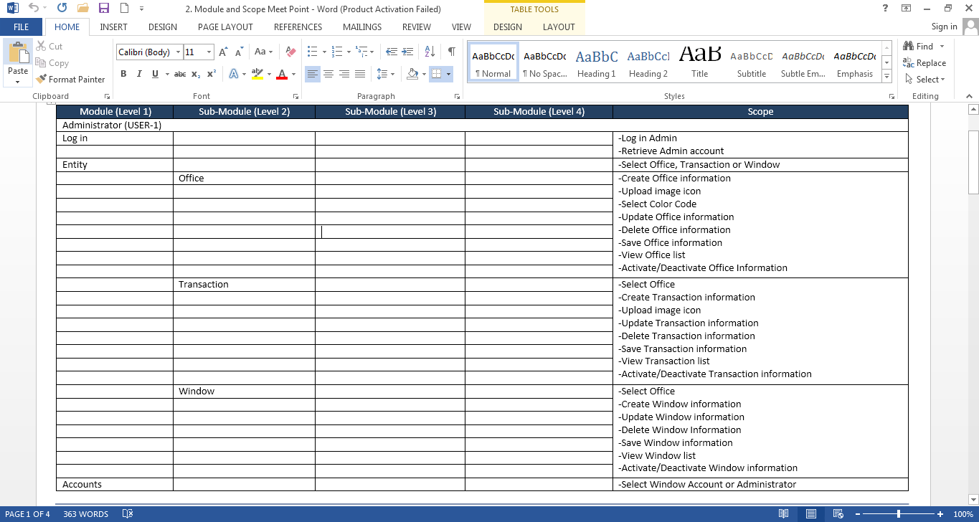

**Figure 1.** Module and Scope Meet Point

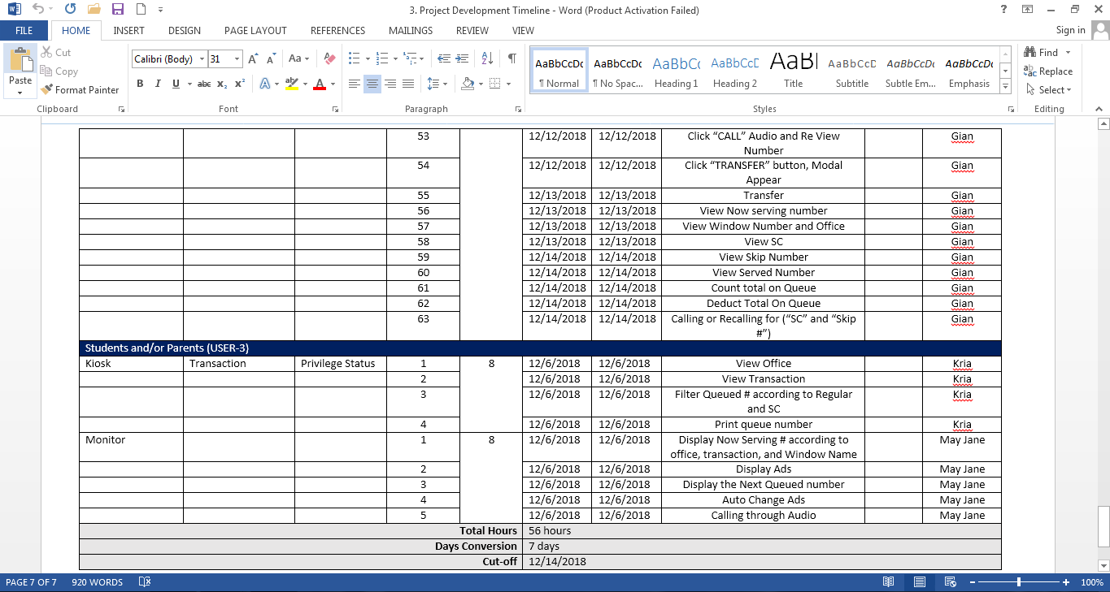

**Figure 2.** Project Development Timeline

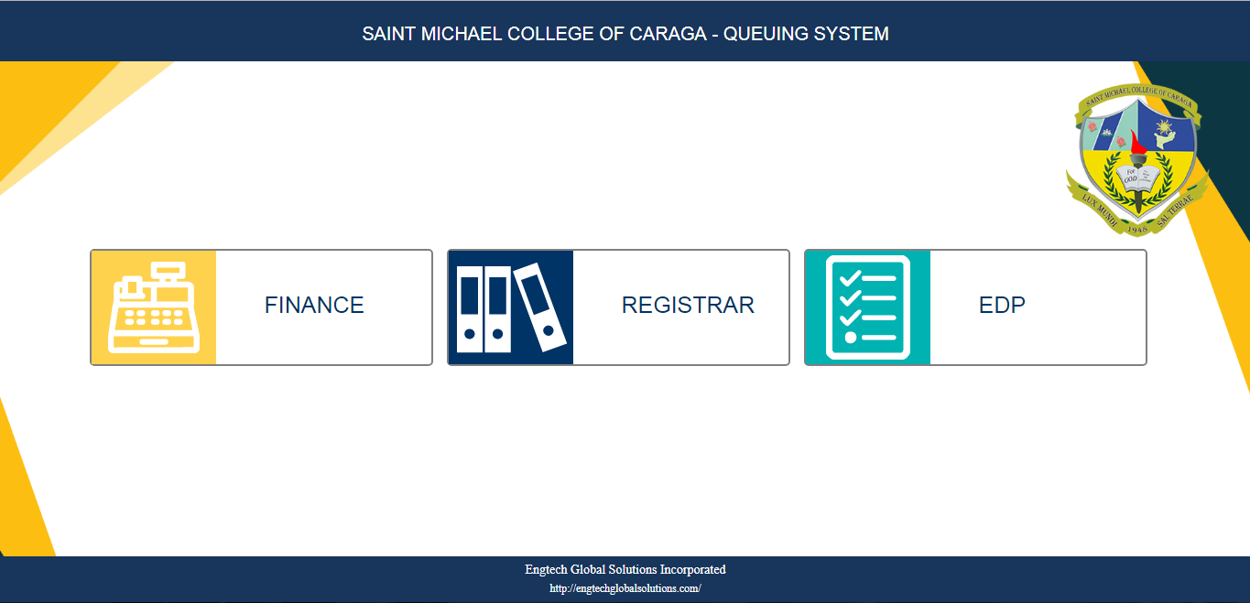

**Figure 3.** Queuing System – Kiosk

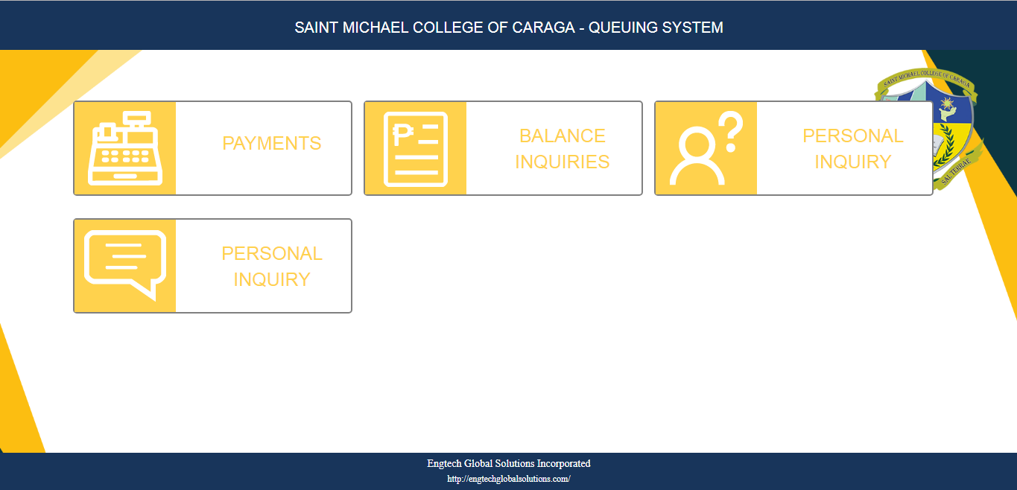

**Figure 4.** Queuing System – Kiosk

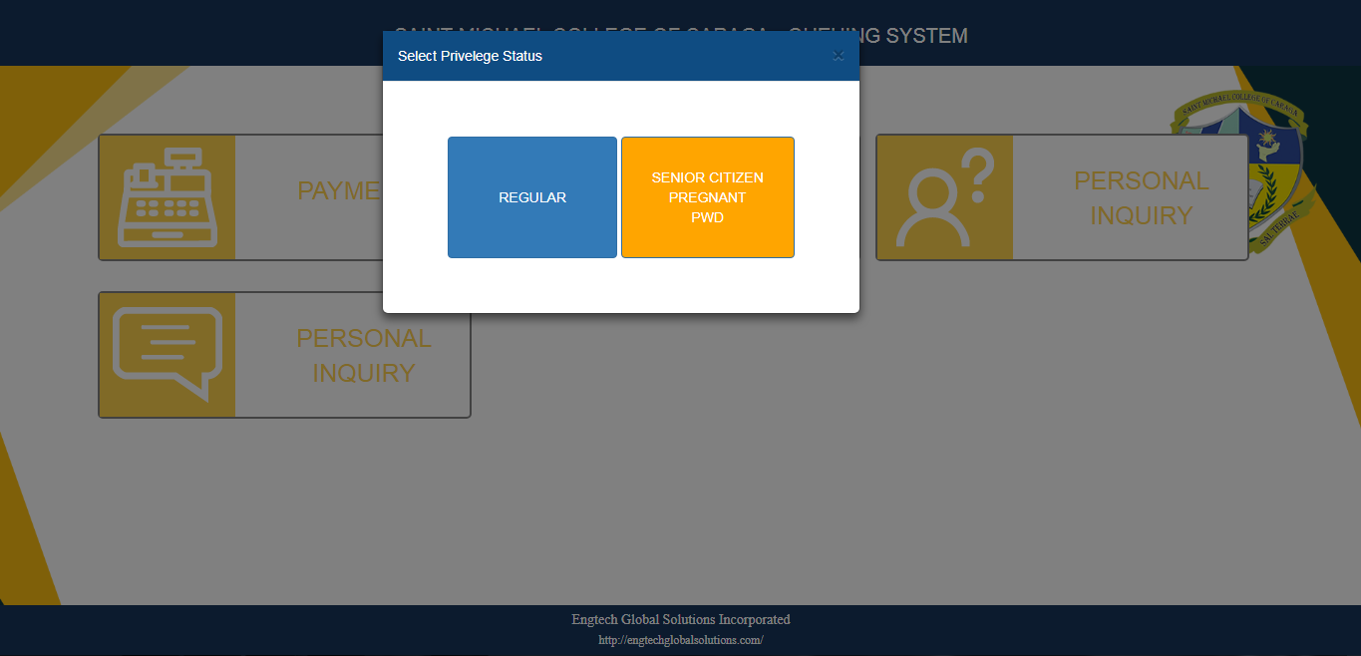

**Figure 5.** Queuing System – Kiosk

1. **Daily Time record (DTR)**
2. **Processing Forms**
3. **Certificate of Completion**
4. **Filled-out Evaluation Form**